IHE Change Proposal

Tracking information:
IHE Domain | Patient care
Change Proposal ID: | CP-PCC-0277
Change Proposal Status: | Submitted
Date of last update:
Person assigned: | Michael Clifton

Change Proposal Summary information:
Conform to R4’s Guidance for Unsupported Modifiers
Submitter’s Name(s) and e-mail address(es): | Richard Kavanagh  richard.kavanagh@graphnethealth.com
Submission Date: | 7th October 2019
Integration Profile(s) affected: | QEDm
Actor(s) affected:
IHE Technical Framework or Supplement modified: | QEDm Rev. 2.1 – 2019-03-06
Volume(s) and Section(s) affected:
Rationale for Change:

In the current text the following is included which states how search modifiers should be processed, specifically any modifieres that are encountered that are not part of QEDm.
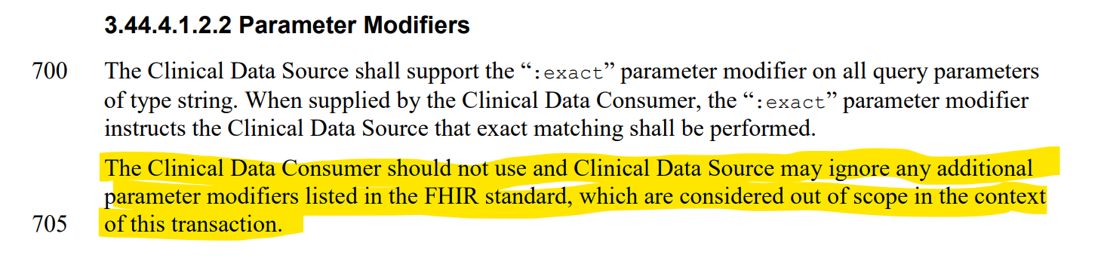
However, when looking at the R4 standard, it includes the following. The last paragraph seems to contradict the QEDm position and as such QEDm appears to be non conformant.

